THE FUNDING PROCESS THANKS TO THE FOUR PLANNING AND DEVELOPMENT DISTRICTS
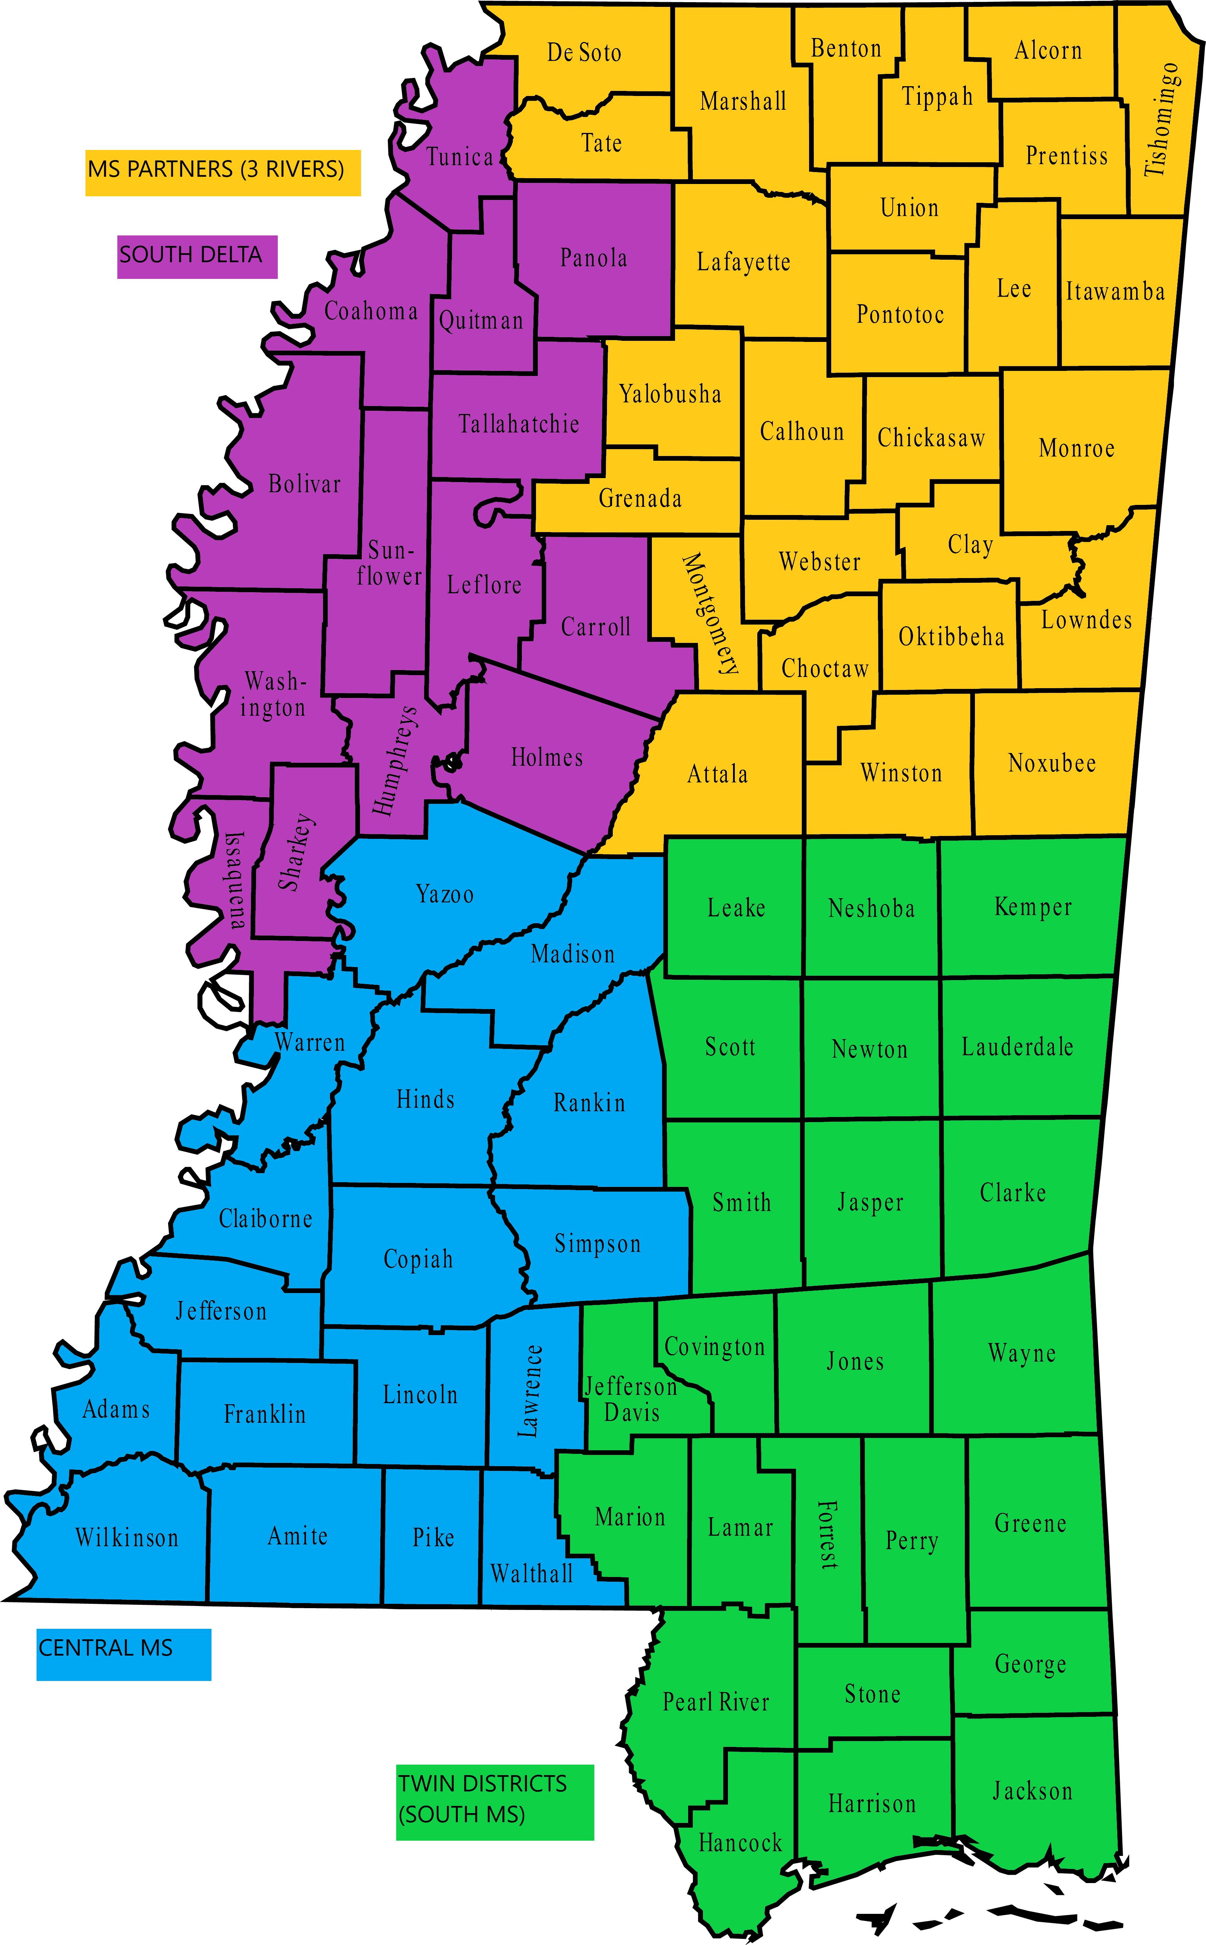


2024 Mississippi Student Nurse Summer Externship Program
aka The Externship Program

The following outlines the process of
Funding provided by the four Mississippi Planning and Development Districts

The Externship program is supported financially by the four Planning and Development Districts across the state.
Each PDD has its own requirements for its district. The afternoon breakout sessions will explain those.
MCQW’s overall funding process is as follows:

- LaNelle Weems (aka the MCQW office) finalizes contracts with each Planning and Development District.
- At the same time, Robin Powell (aka the MCQW office) is accepting applications for participation.
Deadline to apply is January 31, 2024. If more time is needed to provide required attachments, please email rpowell@mhanet.org to work out a due date.
- When the application process is complete, the MCQW office assigns the approved number of slots defined in the contract with each approved hospital in each PDD. The number each hospital receives depends on the number of applications approved and the number of approved funded slots. If the hospital does not use its funded slot(s), it communicates that to the MCQW office and the slot is offered to another hospital in the same district.
- The MCQW office communicates the number of funded slots to each approved hospital by sending the hospital POC an MOU to get signed by their authority and returned to the MCQW office.
- The hospital can hire as many externs as it chooses, paying them through the hospital budget. The funding is specific only to the externs assigned a funding slot, communicated to the hospital by the MCQW office on the MOU.
- The funded extern must have residence in the same planning and development district that gives the funding.
- The MCQW office provides the hospital POC with a spreadsheet to complete, giving the contact information on the funded extern(s) as well as a reimbursement form for the hospital to use to report hours worked.
- The hospital POC ensures the funded extern(s) complete the WIN Job Center registration process as soon as possible. This process will be explained in the funding webinar.
- The hospital hires the extern(s) and pays them through the hospital payroll process. The approved rate of pay for an extern is $15 / hour. The approved reimbursement rate is $12/hour.
- The hospital will submit accurate, legible time sheets along with the provided reimbursement form to MCQW to report the extern’s time worked. The extern must work 320 hours in order to pass the summer course. The time can be submitted per the hospital’s payroll calendar or at one time at the end of the 320 hours. The time sheets submitted to MCQW must be clearly understandable to someone outside of the work environment.
- MCQW will hold all time sheets received until the 320 hours has been completed by each funded extern. At that time, one check will be submitted to the hospital as reimbursement. The check will be mailed to the person / address provided by the hospital POC.
- The reimbursement is calculated as $12 / hour worked plus .1065 fringe.
- The reimbursement does not pay for overtime, holidays, or personal time off. The reimbursement is for hours worked only at $12 hour plus .1065 fringe. Example –
  - one extern that completes the 320 hours equals
$12 x 320 = $3840 (salary)
  - $3840 x .1065 = $408.96 (worker’s comp)
  - $3840 + $408.96 is a total reimbursement of $4248.96 per extern

Robin Powell, Project Manager
MS Center for Quality and Workforce
MHA Health, Research and Educational Foundation, Inc.
rpowell@mhanet.org | 601 368 3321
www.mcqw.org | WORKFORCE tab

